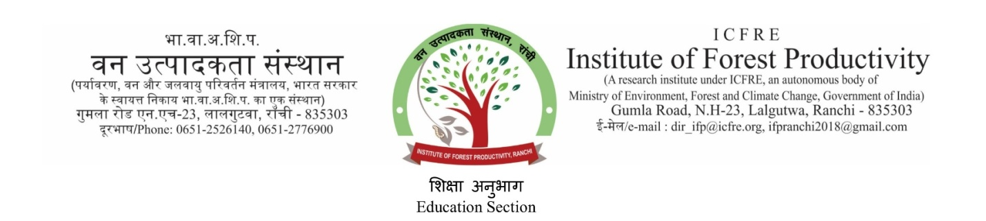

Dissertation Training Programmes for Practical Exposure to the students pursuing Academic Degree (B. Sc/ M.Sc/ B. Tech/ M. Tech) in Biotechnology and Forestry related fields

Sl | Subject Area | Duration and Fee details
 |  | One month  (in Rs.) | Two months  (in Rs.) | Three months  (in Rs.) | Six months  ( >3 months to  6 months)
 | Molecular Biology | 6000/- | 10000/- | 16000/- | 20000/-
 | Tissue Culture | 6000/- | 10000/- | 10000/- | 15000/-
 | Others  (Soil Science, Tree Physiology, Geo-informatics, Biochemistry/ Chemistry, Silviculture, NTFP and Medicinal plants, Entomology) | 1500/- upto 15 days  3000/- upto one month | 5000/- | 8000/- | 12000/-
Caution Deposit (refundable) :- Rs. 2000/-

Terms & Conditions

- Eligibility :
(i) B.Sc. / B. Tech Dissertation: Pursuing graduation in Science/ B. Tech or equivalent with consistent good academic record.
(ii) M.Sc. / M.Tech Dissertation: Pursuing M. Sc./ M. Tech or equivalent with graduation in any discipline.

- Fee should be paid at the Institute during week days from 9 am to 5 pm in cash or by Demand Draft drawn in favour of Director, ICFRE-Institute of Forest Productivity, Ranchi, payable at Ranchi. Payment of fees should be made before commencing the project work.

3. No accommodation will be provided by the Institute.

4. The Scientists/Officers of the Institute under whose guidance students pursue their project work shall be the guide/supervisor and the concerned faculty member in their college/Institution shall be the co-guide or co-supervisor.

5. Dissertation of candidates with less than 80% attendance will not be certified by the Guide / Institute and such students shall not be allowed to pursue the work further and project so allotted shall be cancelled.

6. After completion of project work, students are required to present the progress of work in a seminar/s arranged by their guide/supervisor before submitting the final dissertation.

7. The dissertation shall bear a certificate duly signed by the guide/supervisor of the student and Director of the Institute or his nominee that the work was undertaken in the Institute and the students has successfully completed the stated objectives.

8. One copy of final corrected version of dissertation bearing signature of Guide/Supervisor and Director of the Institute shall be submitted to Institute.

9. All publications resulting out of the work done in the Institute shall be processed through the guide/supervisor in the Institute.

10. The students shall be responsible for the safety of the instruments/lab facilities which they are allowed to use and damages attributed to them shall be recovered from the caution deposit.

11. If students misbehave, indulge in mischief, damage any property or disturb the tranquillity during their stay in the Institute, the allotted project work will be cancelled, fees forfeited and students will be sent back under intimation to their Head of Institution and parents of the students.

